Experiences and lessons managing water in Cape Town with the advent of ‘Day Zero’
Robbie Parks, Megan McLaren, Ralf Toumi, Ulrike Rivett

Chapter 1: Introduction
- ‘Water is a natural resource that is embedded in the cultural and religious values of societies. It is what we take pictures or create paintings of. It is why we construct fountains.’¹
- Hydrological drought is associated with precipitation shortage on a longer time scale (12 months to 2 years or more).

The challenge of water management and drought globally
Importance of good water management
- Demand for water is growing, both due to population increases, changing diets, as well as changes in the way people aspire to use water.
- ‘There are many regions where our freshwater resources are inadequate to meet domestic, economic development and environmental needs’.¹
- ‘In recent decades the percentage increase in water use on a global scale has exceeded twice that of population growth’.¹
- ‘1 of every 6 units of water treated across the United States never reaches the consumer.’²

Globalization of water
- ‘Virtual water’ is the water used in production of a commodity (e.g. food), produced locally to then be exported around the world. This affects local real water supplies.³

Changing supply and demand patterns due to climate change
Growing urban demand
- ‘Urban water demand will increase by 80% by 2050, while climate change will alter the timing and distribution of water’.⁴
- More than 27% of cities studied, containing 233 million people, will have water demands that exceed surface-water availability.⁴
Freshwater stress under climate change
- ‘Adaptation to global change must include prudent management of groundwater as a renewable, but slow-feedback resource in most cases. Groundwater storage is already over-tapped in many regions, yet available subsurface storage may be a key to meeting the combined demands of agriculture, industry, municipal and domestic water supply…’⁵
- ‘The highest vulnerabilities are found at the North African rim of the Mediterranean Sea, in southwestern Africa, in northeastern Brazil and in the central Andes, which are areas of moderate to high sensitivity.’⁶
- ‘Groundwater—the world’s largest freshwater resource—is critically important for irrigated agriculture and hence for global food security’.⁷
- Rivers/Dams (focussing on Africa): Perennial river flow (and hence how water reservoirs are filled) is extremely sensitive to changes in precipitation. Drops of up to 20% predicted in southern Africa, including South Africa and Cape Town (‘Changes in Surface Water Supply Across Africa with Predicted Climate Change’, de Wit, Stankeweicz, Science, link)
Monitoring use/new technologies
- Give a brief taste of where it’s going in section 3…

Overview of water and drought in Cape Town and South Africa
South Africa
- High drought frequency but relatively low intensity.⁸
- ‘Drought is a regular feature of the South African climate’.⁹
- Drought strongly driven by ENSO and SST anomalies in Indian and South Atlantic Oceans.¹⁰
- No clear trend in precipitation over the past 3 decades.¹⁰
- Studies of the normalised vegetation index dataset (Los et al., 1994) show that the impact of droughts on vegetation (Farrar et al., 1994) is particularly strong where annual rainfall amount varies from 300 to 500 mm (Richard and Poccard, 1998). This is the case for most of South Africa.⁹
- Fig:2 Global urban water security (n=482).⁴
Cape Town
- Total precipitation ~749 mm per year.¹⁰
- Highest precipitation in June/July/August.
- Opposite precipitation pattern to inland and east part of country.
- Water usage before Day Zero was around 60% of Capetonians using more than 87 litres per day. (link)

Usefulness of Cape Town as an example of an industrialised city in a semi-developing country
- Overview of sustainable development goals:¹¹
· 6: Clean water and sanitation
· 11: Sustainable cities and communities
· 12: Responsible consumption and production
- Statistical comparison:¹² (to London/NYC/Sydney/Tokyo/Berlin/Paris etc.)
· GDP per capita: R76 420 (£4,307)
· GDP annual growth rate ~3.7% a year
· Main industries: Finance and insurance largest contributor to growth rate
· Urbanisation: rapid urban growth (statistic?)
· Population: 4,131,729 by 2020
· South Africa is one of the most inequitable countries in the world, with a 2014 Gini coefficient of 0.64. South Africa is slightly lower at 0.62 (comparison of UK/London

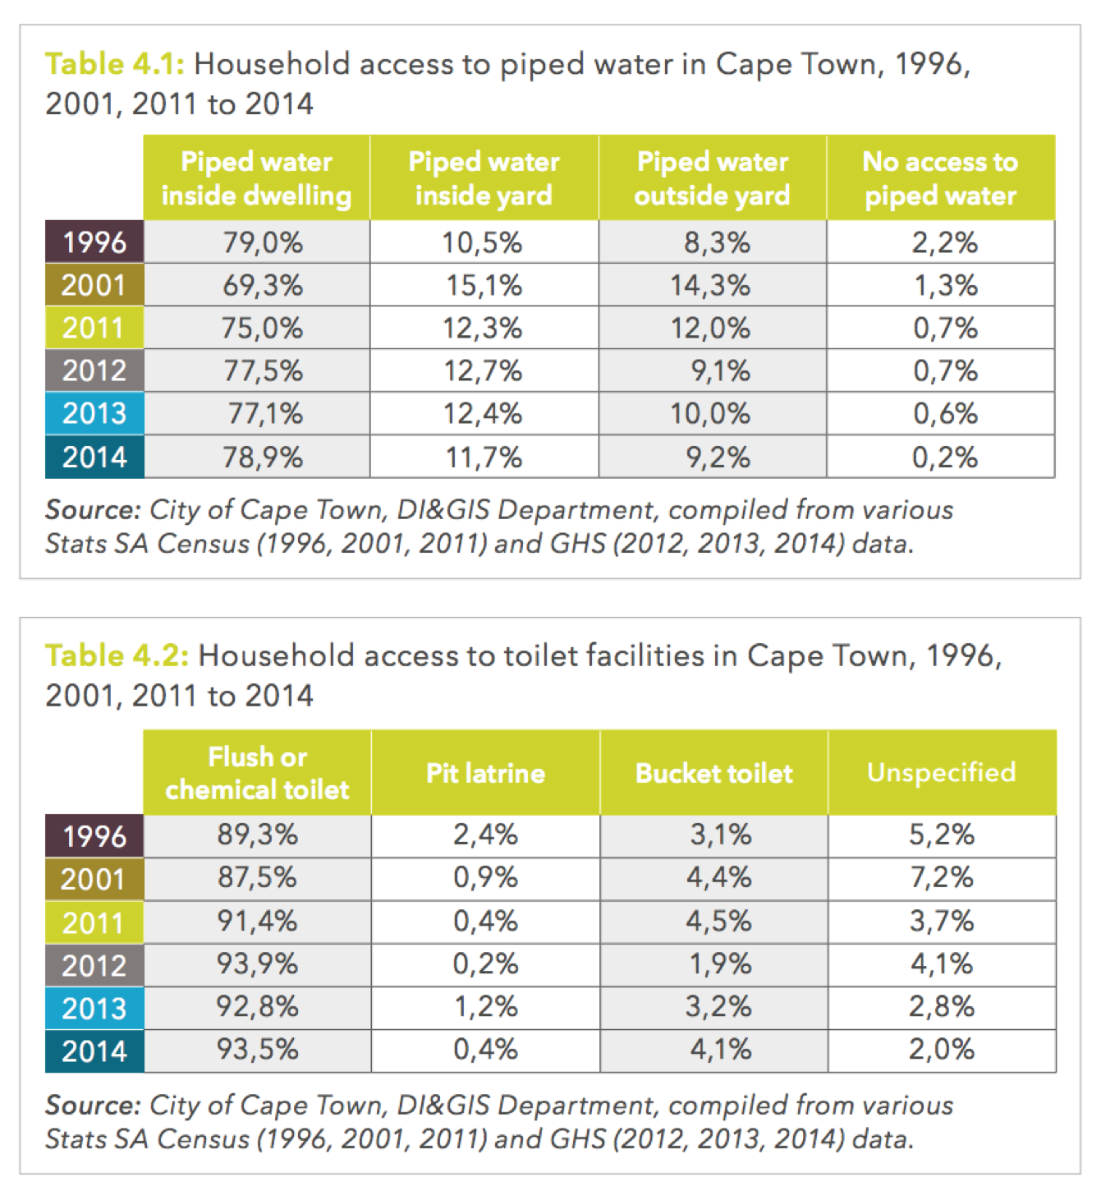
- Comparison of water footprints of Cape Town and other industrialised cities¹³¹⁴

Water guarantee in the South African constitution
- Added in 1996 (link) ‘Section 27: the rights to food, water, health care and social assistance, which the state must progressively realise within the limits of its resources’.¹⁵

5. Main supplies and uses of water in South Africa and Cape Town
Governance of water supplies
- Clash between political parties and local and national governance. Political squabbling.
- Declaring a particular drought as a disaster having political and management consequences.
Overview of surface water
- Berg River, Steenbras Upper, Steenbras Lower, Theewaterskloof, Voëlvlei, Wemmershoek, (link)
Rainfall in South
- Strong inter-annual variability rainfall variability since 1970.⁹
- Total rainfall in Cape Town per year 749mm (average of latter half of 20th century) ⁹
Uses of water in South Africa and Cape Town
- South Africa stats below (also explore Stats SA)
· Explanation of blue/green/grey water link:

Source link of below
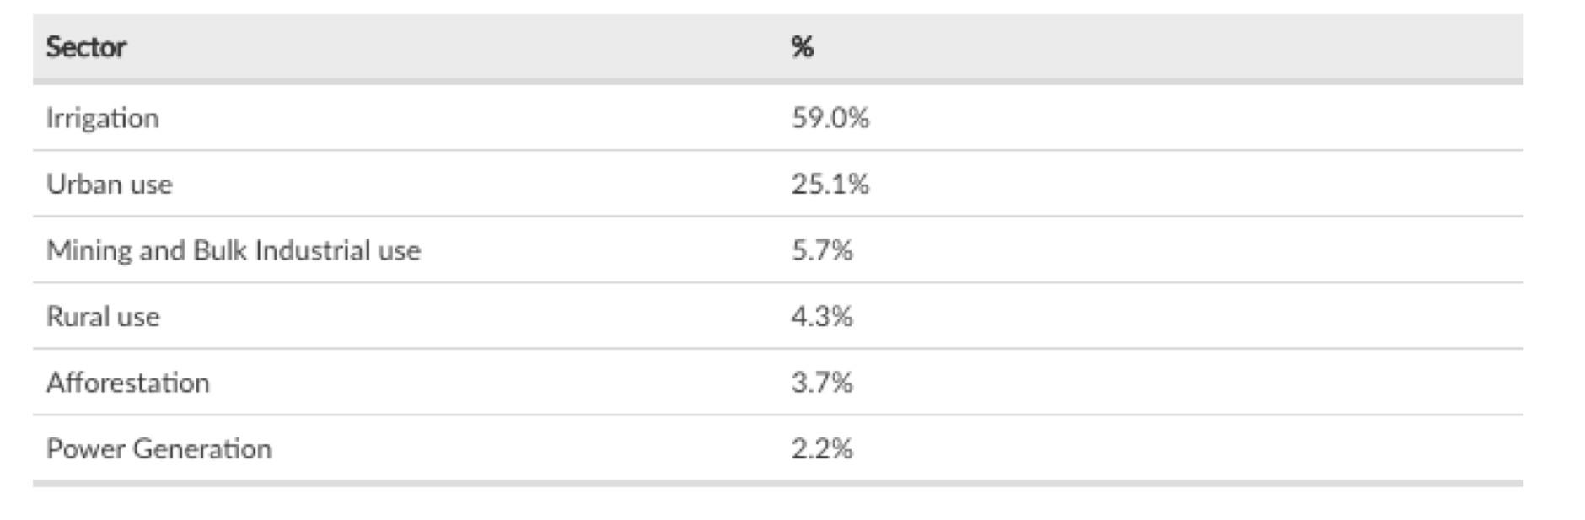
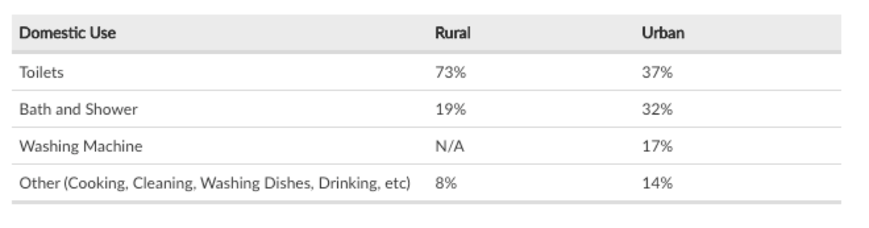
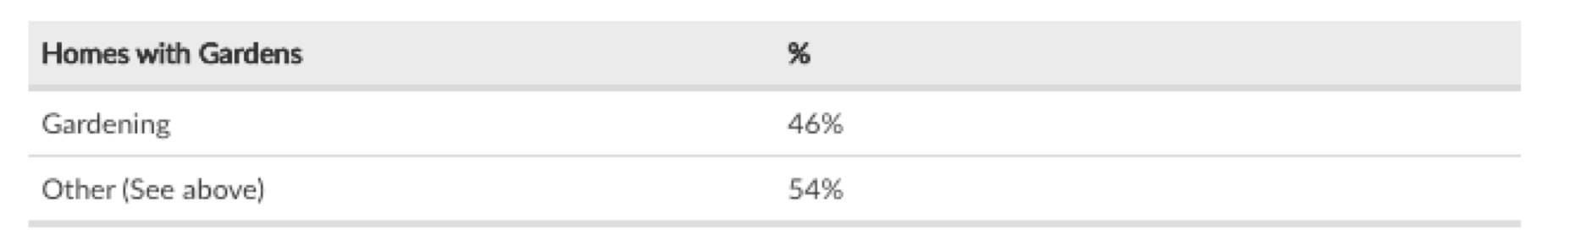
- Cape Town stats below (link):
o Formal housing compared with informal settlements
o Much much less water in informal settlements, although the vast majority of population.
- While most people are living from taps, richest section using most do not actually do this and so are the ones experiencing rationing for the first time

Overview of Cape Town’s seasonal water cycle and supply
https://citymaps.capetown.gov.za/waterviewer/
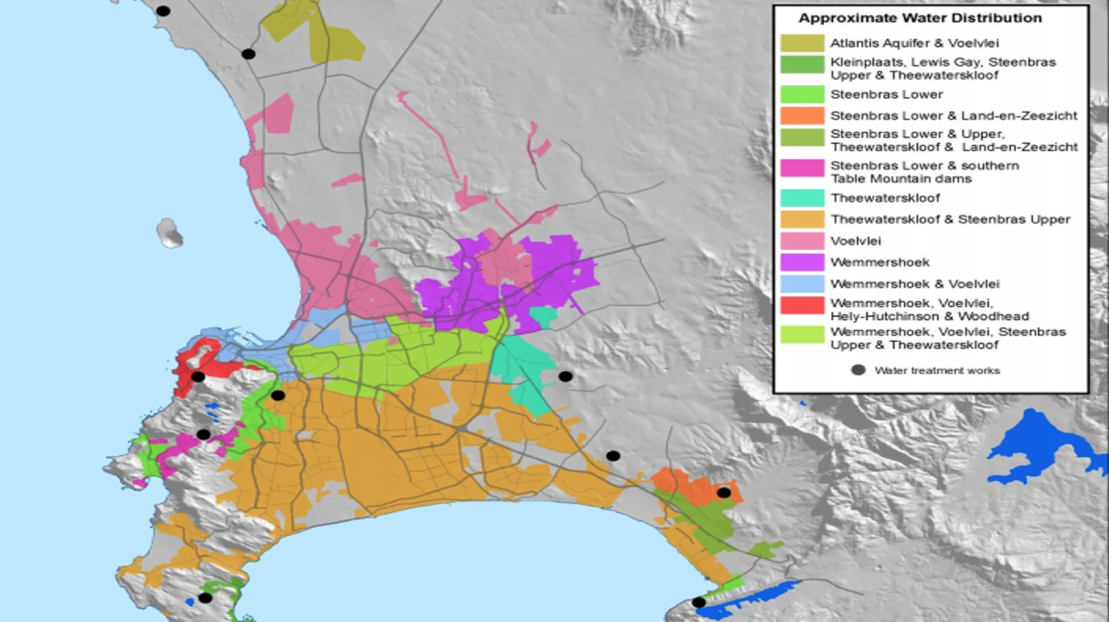
http://www.thewatershedproject.co.za/wp-content/uploads/2015/05/Where-does-my-water-come-from-1.jpg)
- City has six big dams as sources of water. (link)

